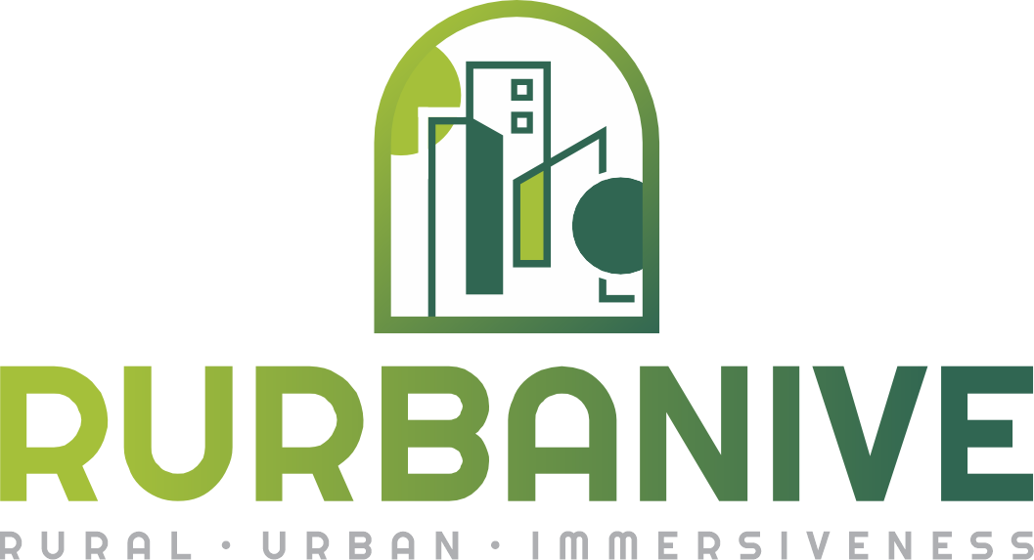

Press release

RURBANIVE project bridges rural-urban social and technological divides

Embarking on a transformative journey, the Horizon EU project “RURBANIVE” has been officially launched, led by a consortium of experts, this ground-breaking initiative seeks to revolutionise the dynamics between urban and rural areas through the power of immersive technologies and innovative strategies, engaging a diverse range of stakeholders, including citizens, civil authorities, policymakers, and other actors fostering knowledge exchange and innovative solutions.

In response to global challenges such as economic downturns and the pandemic’s impact, RURBANIVE aims to address regional inequalities. At its core is the creation of a dynamic community store, serving as a hub for experimentation, innovation, and co-creation, fostering bi-directional urban-rural synergies. Exploiting the endless capabilities of Extended Reality, RURBANIVE will develop six Rural-Urban enablers - innovations in six domains known to favour bi-directional urban-rural synergies and a well-being economy.

Co-creation Labs with tech innovations all over Europe

Throughout the project, seven Rural-Urban Co-creation Labs in diverse geographic and socio-cultural contexts will be outfitted with social and technological innovations. Two of them will take place in Greece: one on the island of Milos, addressing low diversification of ecosystem restoration and integration with agriculture, and one in Trikala, addressing areas underserved by public transport and unsustainable cultural tourism. The lab in Lower Austria will attempt to deal with transporting resources from rural areas and the economic stagnation, focusing primarily on circular bio economy and improvement of the supply chain. The lab in Prague Suchdol will cope as well with the improvement of logistics, shortening the value chains, nurturing user engagement, and raising society and territorial awareness. Burgos province in Spain will also be one of the co-creation labs’ locations, addressing rural depopulation and sustaining cultural tourism. The Rural-Urban Cocreation Lab’s main challenge in the City of Lemgo (Germany) is commuting to work and engagement towards business opportunities, while the lab at Kedainiai municipality in Lithuania will address low innovation, institutional thickness, and a city-centric regional outlook.

Fostering synergies through a Community Store

RURBANIVE aims to provide the required technical and economic solutions, covering a representative variety of European rural areas to facilitate the design of positive governance frameworks and policy interventions for rural communities. In such an immersive environment, end-users can create, co-design, co-create, and engage with others while challenging their status quo, where alternative ideas and opportunities become real. The envisioned community store will contribute towards:

- Improving logistics, and shortening value chains (towards climate neutrality);
- Ecosystem and biodiversity restoration (preserving ecosystems);
- Circular economy (environmental quality);
- User engagement, empowerment, society and territorial awareness (social well-being, rural jobs and growth, and development prospects);
- Culture, landscape and heritage access and promotion;
- Enhanced mobility;

The digital space of “Community Store”, which is the prominent result of the project, will integrate the enablers along with the “Community of Practice Suite” of Policies, facilitating rural and urban communities to create strong synergies supporting online interaction, dialogue, collaboration, and participation of rural-urban actors and stakeholders. Together, they will enable rural-urban interactions through enhanced social connectivity, cooperation, and instant realisation. Participatory processes will support dialogue and cooperation and enable stakeholders to assess and evaluate processes and future scenarios that contribute further to the development of synergies and recommendations.

As Dr. Amditis, project coordinator, and Research & Development Director of ICCS/NTUA states “RURBANIVE is a research project that combines social and technological innovation and it's an honour for our institute to lead it. Our consortium envisions a future where rural areas are immersed and included in the technological progress, and no longer left behind, by adopting and adjusting the urban advances to the rural reality. RURBANIVE's successful kick-off meeting indicated an engaged project team focused on the successful implementation of our plan.”

The RURBANIVE project kicked off officially on the 15th and 16th of February 2024 in Athens, bringing together 17 partners from 8 different countries. The consortium includes Institute of Communication and Computer Systems (ICCS) which serves as the project’s coordinator, Agricultural University of Athens (AUA), Fundación CARTIF, RISE Research Institute of Sweden, Foodscale Hub (FSH), European Association for Innovation in Local Development (AEIDL), Czech University of Life Sciences Prague (CZU), Alchemia-nova research and innovation (ANRI), AgriFood Lithuania (AFL), IMERYS, The Lisbon Council for Economic Competitiveness and Social Renewal (LC), Trikala Municipality (e-trikala), Kedainiai District Municipality (KDM), South Aegean Region (SAR), Innovation Campus Lemgo (ICL), Partnership for Rural Europe (PREPARE) and BioBASE.

CZU will set up a rural-urban co-creation lab bringing together food producers, consumers, university and school students, entrepreneurs, and policymakers to deliver the latest know-how in food processing and production, information about financing opportunities and emerging business opportunities, and information on how to innovate food products with state-of-the-art processing technologies (primary producers). This will include increasing consumer awareness about the benefits of consuming locally produced and processed agri-food products and delivering information about how the shortening of the value chain can enable access to quality and healthy agri-food products. CZU will develop a digital platform to deliver four online courses accompanied by immersive digital campaigns and enable interactions among the stakeholders. The team will develop an innovative business model to sustain the online courses and workshops and contribute to disseminating and exploiting project results. It will also contribute to policy recommendations.

By harnessing immersive technologies, the project aims to not only address existing inequalities but also pave the way for a sustainable and inclusive future for all.

Notes to editors
At a glance - Key facts and figures
Instrument | European Commission Funding
EC Funding | € 5.495.530,00
Duration | 4 years, 2024-2027
Consortium | A total of 17 partners from 8 countries

To learn more about the RURBANIVE project and stay up to date, visit https://rurbanive-project.eu/ and follow us on social media:
 |  |  |  | 

Project Coordinator | Dr. Angelos Amditis  Institute of Communication and Computer Systems (ICCS)  Ir. Politechniou 9, Zografou 157 73
Project Communication | George Papapostolou  Foodscale Hub Greece  L.SOFOU 20, 57001 Thermi, Thessaloniki, Greece

Disclaimer
Funded by the European Union. Views and opinions expressed are however those of the author(s) only and do not necessarily reflect those of the European Union or Research Executive Agency. Neither the European Union nor the granting authority can be held responsible for them.

